Host; Want to quit the rat race in weeks? Sidekick: no id rather work hard for 60 years, dummy

Host; Want to make money while you sleep? Sidekick: are you being silly right now?

Host; Want to live financially free once and for all? Sidekick; no, I like being broke

Host; Create unlimited wealth regardless of your income, credit score, or financial situation? Sidekick; my credit sucks, my income is zip, and I have to sell my blood for cash, what do you think?

Host; At the Personal Wealth Project, a nonprofit helping people create wealth for themselves in literally weeks not decades, we have a program that takes you from rags to riches in no time flat.

Host; t's Crazy! Most People Feel 1 hour of financial education Is a Long Time to Get Rich, But Don't Feel 60 Years at A Job Is a Long Time to Stay Broke.

Host; We will help you acquire up to 6 figure funding i with no banks, no documents, no credit scores, no income, no qualifying, all while replacing a job or paycheck in just a few weeks!

Host; That’s not even the best part. We will have the loan paid off for you. Now your money is free and clear.

Host; Just put up 10% of any amount you want to receive funding 500% more in funding, sidekick; hey that’s 5 times my deposit!

Host; yes it is!

Host; Put up $1000 and we do a funding raise to get you $5000 in 30 days! Sidekick: that’s crazy!

Host; And it gets better. We will take 25% of your funding and pay off 100% of the loan for you! Sidekick; So 75% of my money is free and clear to use as I want? Wow , how can this be?

Host; Our trading partner takes over the loan payments for you, he takes 25% of your funding and pays off the loan with profits he generates from that 25%.

Host; And better yet there are no backend success fees, totally free money & no interest charges!

Host; Use other people’s money to get rich, this is how rich get richer. Sidekick; I want to be rich.

Host; Now here is the 2nd part of this amazing free money program… Sidekick; Im all ears

Host; Put whatever amount you want in your own trading account the trader will help you create, and then make 50% returns monthly. Only you can take out funds anytime you want.

Host; 98 out of 100 opportunities & investments never make enough money, overpromise and under deliver, or are just plain bs. Sidekick; yea I got ripped off last year by some scumbags,

Host; We can document every single thing we do with live trading results!

Host; Now, why would we do this for you? Sidekick; I give up why?

Host; Because we run a nonprofit charity for disadvantaged children. Your participation will help 100s of these kids, sex trafficked, physically abused, special needs, foster children, homeless kids.

Host; So, we don’t accept everyone, you must be responsible, patient, humanitarian, and kind. Sidekick; im kind, I love kids to, I can learn to be patient to!

Host; We don’t want the biggest business but one that bothers us the least so we can focus on our Children’s Charity

Host; if you are serious about becoming financially free, creating unlimited wealth, and passing wealth on to your loved ones, while helping 1000s of children who desperately need your help, this is your opportunity.

You can do 999 things wrong; you only need to do 1 thing right. Sidekick: yea, ive made 999 bad decisions, more like 99,000 bad ones, like my ex wives, whew, what a bunch of dingys!

Host; Email us at the email below and lets get you on the right track for 2025! (use [FasterFunding@mail.com](mailto:FasterFunding@mail.com) Sidekick; yea, I know, if someone tells you money doesn’t buy happiness, its because they don’t have any. Im in.

Graphix; Quit The RAT RACE! Put small image of a rat in the wheel in the bottom right corner



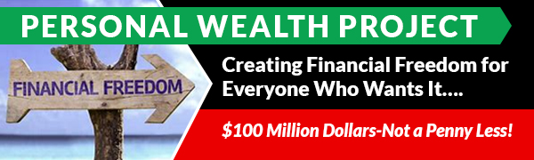



### Host on screen with this graphix below half of screen Graphic;

### **It's Crazy! Most People Feel 2-3 Months Is A Long Time To Get Rich, But Don't Feel 60 Years At A Job Is A Long Time To Stay Broke**

 HOST ON camera rest of vo

 bottom graphix across the bottom of this image : **Loan Is PAID OFF for you!**

Video of the spokesgirl, graphix below:

Our Trader Pays Off The Entire Loan For You! FREE MONEY



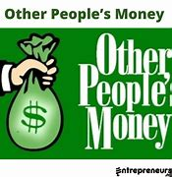

Spokesgirl on camera reading this; Now here is the 2nd part of this amazing free money program…

 (image starts then the girl after 2 seconds

Girl on camera; Then take out profits every month if you want!

Girl on camera: 98 out of 100 opportunities & investments never make enough money, overpromise and under deliver, or are just plain bs.

We can document every single thing we do with live trading results!

Now why would we do this for you?

on screen entire vo line

 

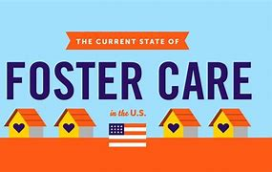

Video on girl;

So, we don’t accept everyone, you must be responsible, patient, humanitarian, and kind.

Video girl on camera during this:

So, we don’t accept everyone, you must be responsible, patient, humanitarian, and kind.

(new image coming)

Video girl on camera;

if you are serious about becoming financially free, creating unlimited wealth, and passing wealth on to your loved ones, while helping 1000s of children who desperately need your help, this is your opportunity.

You can do 999 things wrong; you only need to do 1 thing right.

On the bottom of the girl run this website: ChildSafeProject.Org